 Tesla, Inc. is an American multinational automotive and clean energy company headquartered in Austin, Texas.

**Goals :** The Goal of Tesla is to accelerate the world’s transition to sustainable energy.” And the Tesla vision statement is “to create the most compelling car company of the 21st century by driving the world’s transition to electric vehicles”

**KPIs :** The KPIs used by Tesla to measure progress towards their goals are

Vehicle Deliveries: The number of vehicles delivered each quarter reflects their sales performance and market demand.

Vehicle Production: Tesla tracks the number of vehicles produced to meet demand and assess their manufacturing efficiency.

Market Share: Tesla often measures its market share in the electric vehicle (EV) industry, comparing it to traditional automakers.

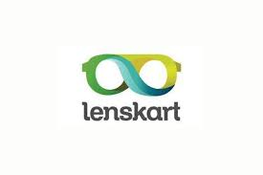Customer Satisfaction: Measuring customer satisfaction through surveys or feedback helps Tesla gauge how well they meet customer expectations.

Lenskart is an Indian multinational optical prescription eyewear retail chain, based in Gurugram. As of March 2023, Lenskart has more than 2,000 retail stores, three-fourths of which are in India.

**Goals :** An aim to provide every Indian access to high-quality designer glasses without shelling out their pocket.

**KPIs :**

**Customer Acquisition Cost (CAC):** CAC represents the cost associated with acquiring each new customer. Lenskart may strive to reduce CAC while increasing customer lifetime value.

**Repeat purchase Rate**: This KPI measures the percentage of customers who make more than one purchase from Lenskart. Encouraging repeat purchases is often more cost-effective than acquiring new customers.

**Website Traffic and User Engagement**: Lenskart may monitor website traffic, bounce rates, time spent on the site, and the number of pages viewed to assess the effectiveness of their online presence.

**NPS (Net Promoter Score):** NPS measures customer loyalty and willingness to recommend Lenskart to others. High NPS scores indicate strong brand advocacy.

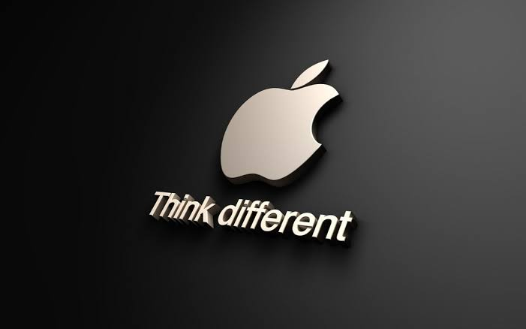

Apple Inc. is an American multinational technology company headquartered in Cupertino, California. Apple is the world’s largest technology company by revenue, with US$394.3 billion in 2022 revenue.

**Goals :** Apple’s mission statement is “to bring the best user experience to customers through innovative hardware, software, and services.” Apple’s vision statement is “to make the best products on earth and to leave the world better than we found it.”

**KPIs :**

**Revenue and Profit:** Apple closely monitors its total revenue and profit, which reflect the overall financial health and success of the company.

**Average Selling Price (ASP):** ASP measures the average price at which Apple’s products are sold. It helps assess the company’s pricing strategy and product mix.

**Market Share:** Apple may monitor its market share in various product categories, such as smartphones, tablets, and personal computers, to gauge its competitive position.

**R&D Investment:** Apple invests significantly in research and development. Tracking R&D spending reflects its commitment to innovation.

**Employee Satisfaction and Diversity:** Monitoring employee satisfaction and diversity metrics helps assess workplace culture and inclusion efforts.

Godrej Group is an Indian multinational conglomerate headquartered in Mumbai, Maharashtra, which is managed and largely owned by the Godrej family.

**Goals :** Strategy to achieve their sustainability goals includes initiatives ranging from energy efficiency, water conservation, waste management and greenhouse gases reduction to promoting certified green buildings, factories and products.

**KPIs :**

**Brand Equity:** Brand recognition and equity can be measured through surveys and customer sentiment analysis to assess the strength of Godrej’s brand portfolio.

**Customer Satisfaction:** Measuring customer satisfaction and loyalty helps Godrej maintain a strong customer base across its various product categories.

**Occupancy Rates and Real Estate Metrics:** For its real estate ventures, Godrej may monitor occupancy rates, rental income, and property development metrics.

**CSR (Corporate Social Responsibility) Initiatives:** Godrej may track KPIs related to its CSR initiatives, such as the impact of community development projects and philanthropic contributions.

**Digital Transformation**: In today’s digital age, tracking digital transformation KPIs, such as online sales growth and digital marketing effectiveness,and be important.



Royal Enfield was a brand name under which The Enfield Cycle Company Limited of Redditch, Worcestershire sold motorcycles, bicycles, lawnmowers and stationary engines which they had manufactured.

**Goals :** Their mission is to get more & more people to discover the joy of riding & follow their pursuit of exploration.

**KPIs :**

**Dealer Network Expansion:** Royal Enfield monitor the growth of its dealer network to improve geographic coverage and accessibility to customers.

**Motorcycle Sales:** Tracking the number of motorcycles sold is a fundamental KPI for evaluating the company’s sales performance.

**Average Selling Price (ASP):** ASP measures the average price at which Royal Enfield motorcycles are sold, which helps assess the company’s pricing strategy.

**Safety and Compliance:** Ensuring motorcycle safety and compliance with industry standards is crucial, so safety and compliance metrics may be monitored.

**Employee Satisfaction and Training:** Measuring employee satisfaction, retention rates, and the effectiveness of training programs helps maintain a skilled workforce.